Dimensions shown include glass engagement (Georgian & Lead only)
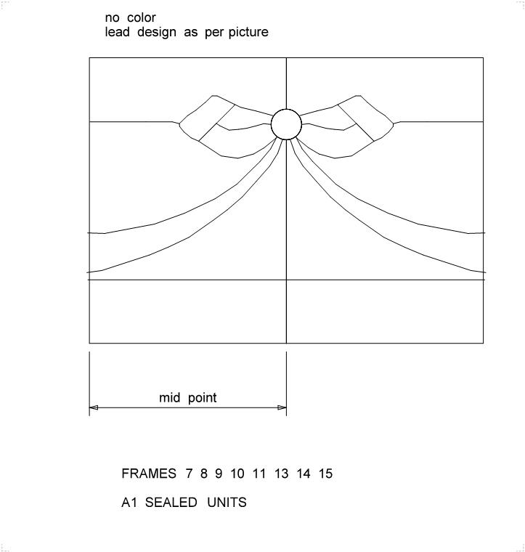
Special designs will be subject to technical approval.
I agree to theLeaded Light & Special Design illustrated
Customer’s Signature: |  | Date: | 14/11/2013

